***Project Design Phase-II***

***Technology Architecture & Stacks***

|  |  |
| --- | --- |
| **Date** | 30 October 2022 |
| **Team ID** | PNT2022TMID26022 |
| **Project Name** | Smart Solutions for Railways |
| **Maximum Marks** | 4 Marks |

***Technical Architecture:***

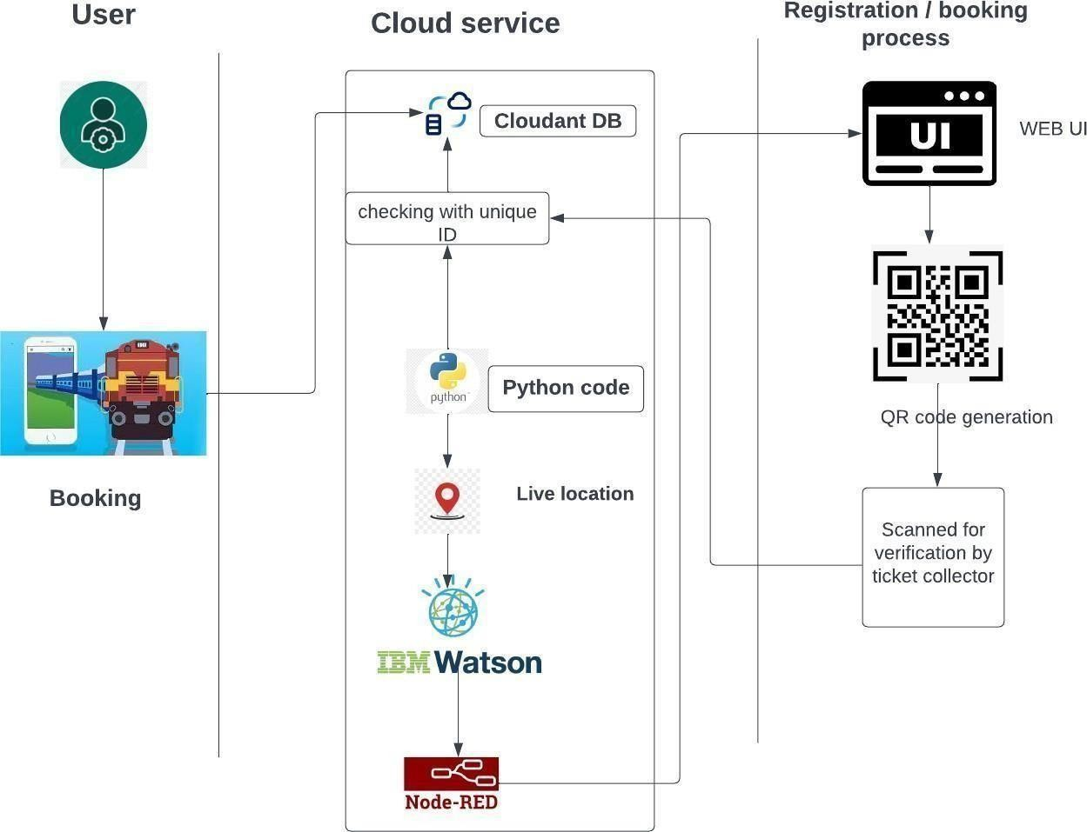

***Table-1 : Components & Technologies:***

|  |  |  |  |
| --- | --- | --- | --- |
| ***S.NO*** | ***COMPONENT*** | ***DESCRIPTION*** | ***TECHNOLOGY*** |
| ***1.*** | ***User interface*** | Web & Mobile Application | Node red UI and MIT App Inventor |
| ***2.*** | ***Application logic-1*** | Sending Random Latitude and Longitude for the train location tracking. | Python |
| ***3.*** | ***Application logic-2*** | Generating QR Code which holds the unique ID. | Node RED. |
| ***4.*** | ***Database*** | Data Type, Configurations etc. | MySQL & Maria Database |
| ***5.*** | ***Cloud Database*** | Database Service on Cloud | IBM Cloudant |
| ***6.*** | ***File Storage*** | File storage requirements | IBM Block Storage |
| ***7.*** | ***External API-1*** | To show the current location of the Train using the map api. | World Map API |
| ***8.*** | ***External API-2*** | Used to send the Email for the user which is used for the verification. | Email Sending API, |
| ***9.*** | ***Infrastructure (Server / Cloud)*** | Application Deployment on Server. | Kubernetes. |

***Table-2: Application Characteristics:***

|  |  |  |  |
| --- | --- | --- | --- |
| ***S.NO*** | ***COMPONENT*** | ***DESCRIPTION*** | ***TECHNOLOGY*** |
| ***1.*** | ***Open-Source Frameworks*** | MIT App Inventor, Flask | Block Based Programming Language, python |
| ***2.*** | ***Security Implementation*** | User Details and Entered Data will be Encrypted. | Industry-Standard AES-256 encryption |
| ***3.*** | ***Scalable Architecture*** | The Scanner code written are highly scalable where any implementation or modifications can be done when ever it required. | Python. |
| ***4.*** | ***Availability*** | As 90% of the process is done by Cloud service, The Application is available at any time required. | IBM Cloud Service & IBM Load Balancer |
| ***5.*** | ***Performance*** | Thus The Process are complete done through Cloud Service and the Data’s are stored in IBM Cloudant Database, the Performance of this project is high. | IBM Cloud Service, IBM Cloudant Database and Distributed Service. |